Honoring those who give us freedom: 3/2 remembers fallen
April 2, 2007; Submitted on: 04/02/2007 01:45:04 PM ; Story ID#: 20074213454
By Cpl. Lucian Friel, 2nd Marine Division

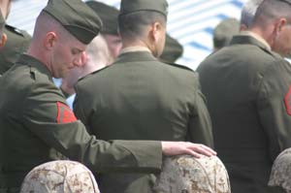

MARINE CORPS BASE CAMP LEJEUNE, N.C.- Marines with 3rd Battalion, 2nd Marine Regiment, 2nd Marine Division, honor the memories of 14 fallen brothers at a memorial ceremony here, March 31. These Marines made the ultimate sacrifice while honorably serving their country in support of Operation Iraqi Freedom in the Al Anbar province of Iraq.

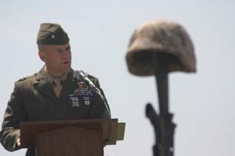

MARINE CORPS BASE CAMP LEJEUNE, N.C.- Lt. Col. Todd Desgrosseilliers, commanding officer of 3rd Battalion, 2nd Marine Regiment, 2nd Marine Division, speaks at a memorial ceremony for 14 fallen Marines here, March 31. These Marines made the ultimate sacrifice while honorably serving their country in support of Operation Iraqi Freedom in the Al Anbar province of Iraq.

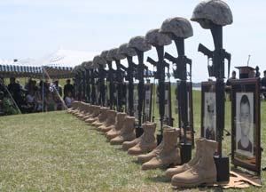
MARINE CORPS BASE CAMP LEJEUNE, N.C.- Fourteen statues of helmets, rifles, dog tags, boots and photographs stand in front of Marines, families and friends of 3rd Battalion, 2nd Marine Regiment, 2nd Marine Division, as they honor their fallen at a memorial ceremony here, March 31. These Marines made the ultimate sacrifice while honorably serving their country in support of Operation Iraqi Freedom in the Al Anbar province of Iraq.

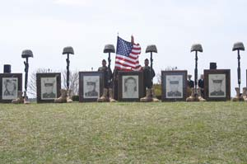
MARINE CORPS BASE CAMP LEJEUNE, N.C.- Statues of helmets, rifles, dog tags, boots and photographs stand in front of Marines, families and friends of 3rd Battalion, 2nd Marine Regiment, 2nd Marine Division, as they honor the 14 fallen heroes at a memorial ceremony here, March 31. These Marines made the ultimate sacrifice while honorably serving their country in support of Operation Iraqi Freedom in the Al Anbar province of Iraq.
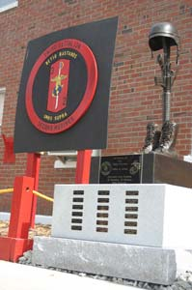
MARINE CORPS BASE CAMP LEJEUNE, N.C.- A new monument for 3rd Battalion, 2nd Marine Regiment, 2nd Marine Division, is revealed after a memorial ceremony for 14 fallen heroes who served with the battalion during its recent deployment to the Al Anbar province of Iraq. The monument honors the 18 Marines with 3rd Bn., 2nd Marines who made the ultimate sacrifice since the beginning of Operation Iraqi Freedom.

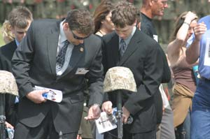

MARINE CORPS BASE CAMP LEJEUNE, N.C.- Families, friends and Marines with 3rd Battalion, 2nd Marine Regiment, 2nd Marine Division, honor the memories of 14 fallen Marines at a memorial ceremony here, March 31. These Marines made the ultimate sacrifice while honorably serving their country in support of Operation Iraqi Freedom in the Al Anbar province of Iraq.

MARINE CORPS BASE CAMP LEJEUNE, N.C. (April 2, 2007) -- The American flag rippled powerfully in the breeze coming off the river water. Fourteen monuments stood still in front of hundreds of families, friends, Marines and sailors. The bright, sunny day could not detract the sorrow felt in the crowded amphitheater. It was clear the monuments were a reminder of the great sacrifices made by the men and women who don the uniform.

Families, friends, Marines and sailors of 3rd Battalion, 2nd Marine Regiment, 2nd Marine Division, gathered to honor the memories of 14 fallen warriors during a memorial ceremony here, March 31.

The Marines made the ultimate sacrifice while serving their country in support of Operation Iraqi Freedom in the Al Anbar province of Iraq.

The battalion was deployed for seven months in Habbaniyah, Iraq, a city just outside Fallujah.

At the ceremony, the battalion’s commanding officer, Lt. Col. Todd Desgrosseilliers, explained the legacy these men were a part of.

“When they became United States Marines, they gave a part of themselves to become something bigger than themselves; members of a band of brothers with a legacy of honor and success in fighting and defeating enemies of our nation throughout its history,” he said.

Marines with the battalion, like Company I commander, Capt. Joseph Burke, gave personal reflections about the men who served fearlessly and died honorably.

“These men were exceptional Marines and great Americans for their service to our country,” Burke said. “They chose, over all other endeavors in life, to serve our country in a time of war, giving up all personal comforts in hopes of bringing freedom to the Iraqi people and the opportunity to kill terrorists who seek to reek havoc throughout the globe. This, my friends, exemplified what these fine men stood for.”

Pfc. Chris Lyon, a Marine with Company K, explained the sorrow that many Marines with the battalion feel.

“Nothing that we can ever say or do can bring back the fallen,” he said. “We try to make sense of death, but we will never understand it. Death always takes the best amongst us first, leaving us with tears and memories of laughter and a resounding ‘why?’ echoing in our heads.”

The ceremony continued with a playing of “Amazing Grace,” the Marine’s prayer, taps and rifle volleys.

After the ceremony, family, friends and fellow service members were able to gather around the Marines’ monuments, which included their Kevlar helmets, rifles, dog tags, combat boots and photographs.

The battalion also honored their fallen warriors with a monument, which is displayed in the battalion area. It has the names of the 18 Marines who have died, while serving with the battalion, in support of Operation Iraqi Freedom.

Desgrosseilliers explained the importance of their heroic actions and why people should never forget them or their sacrifice.

“In their heroic actions, they kept their faith and held the line against terror in Iraq,” he explained. “They did this so Americans could sleep well in their beds at night and in the hopes that one day, the Iraqi people will live their lives in freedom and without fear.”

The Marines honored in the ceremony were Staff Sgt. Gordon G. Solomon, from Fairburn, Ohio; Cpl. David G. Weimortz, from Columbia, S.C.; Lance Cpl. Donald E. Champlin, from Natchitoches, La.; Lance Cpl. Colin J. Wolfe, from Manassas, Va.; Lance Cpl. Cliff K. Golla, from Charlotte, N.C.; Lance Cpl. Philip A. Johnson, from Hartford, Conn.; Pvt. Ryan E. Miller, from Franklin, Ohio; Lance Cpl. Rene Martinez, from Miami; Lance Cpl. Eric W. Herzberg, from Anne Arundel, Md.; Sgt. Luke J. Zimmerman, from Kewaunee, Wis.; Lance Cpl. James E. Brown, from Owensville, Ind.; Cpl. Michael C. Ledsome, from Williamson, Texas; Cpl. Joshua M. Schmitz, from Spencer, Wis.; and Lance Cpl. William C. Koprince Jr., from Lenoir City, Tenn.

“These men will not be forgotten,” Desgrosseilliers concluded.

-30-
MARINE CORPS BASE CAMP LEJEUNE, N.C.- Marines with 3rd Battalion, 2nd Marine Regiment, 2nd Marine Division, honor the memories of 14 fallen brothers at a memorial ceremony here, March 31. These Marines made the ultimate sacrifice while honorably serving their country in support of Operation Iraqi Freedom in the Al Anbar province of Iraq. Photo by: Cpl. Lucian Friel
MARINE CORPS BASE CAMP LEJEUNE, N.C.- Lt. Col. Todd Desgrosseilliers, commanding officer of 3rd Battalion, 2nd Marine Regiment, 2nd Marine Division, speaks at a memorial ceremony for 14 fallen Marines here, March 31. These Marines made the ultimate sacrifice while honorably serving their country in support of Operation Iraqi Freedom in the Al Anbar province of Iraq. Photo by: Cpl. Lucian Friel
MARINE CORPS BASE CAMP LEJEUNE, N.C.- Fourteen statues of helmets, rifles, dog tags, boots and photographs stand in front of Marines, families and friends of 3rd Battalion, 2nd Marine Regiment, 2nd Marine Division, as they honor their fallen at a memorial ceremony here, March 31. These Marines made the ultimate sacrifice while honorably serving their country in support of Operation Iraqi Freedom in the Al Anbar province of Iraq. Photo by: Cpl. Lucian Friel
MARINE CORPS BASE CAMP LEJEUNE, N.C.- Statues of helmets, rifles, dog tags, boots and photographs stand in front of Marines, families and friends of 3rd Battalion, 2nd Marine Regiment, 2nd Marine Division, as they honor the 14 fallen heroes at a memorial ceremony here, March 31. These Marines made the ultimate sacrifice while honorably serving their country in support of Operation Iraqi Freedom in the Al Anbar province of Iraq. Photo by: Cpl. Lucian Friel
MARINE CORPS BASE CAMP LEJEUNE, N.C.- A new monument for 3rd Battalion, 2nd Marine Regiment, 2nd Marine Division, is revealed after a memorial ceremony for 14 fallen heroes who served with the battalion during its recent deployment to the Al Anbar province of Iraq. The monument honors the 18 Marines with 3rd Bn., 2nd Marines who made the ultimate sacrifice since the beginning of Operation Iraqi Freedom. Photo by: Cpl. Lucian Friel
MARINE CORPS BASE CAMP LEJEUNE, N.C.- Families, friends and Marines with 3rd Battalion, 2nd Marine Regiment, 2nd Marine Division, honor the memories of 14 fallen Marines at a memorial ceremony here, March 31. These Marines made the ultimate sacrifice while honorably serving their country in support of Operation Iraqi Freedom in the Al Anbar province of Iraq. Photo by: Cpl. Lucian Friel

